CHAIBABA: A LOCAL BUSINESS
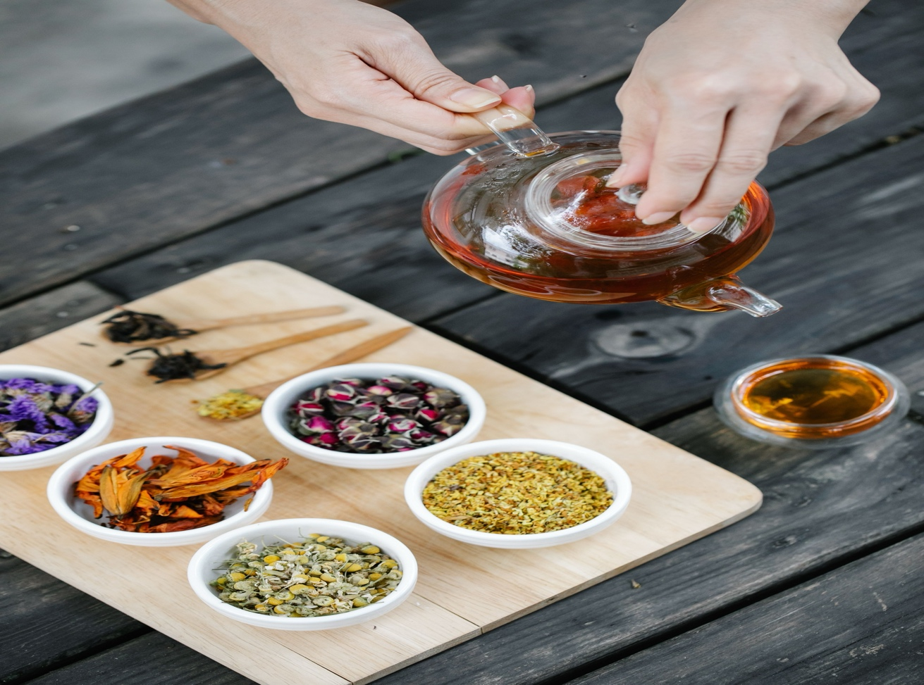

Student Workbook
Elnaz Zamanzade

Video Transcript
Elnaz Zamanzade



CHAIBABA: A LOCAL BUSINESS: Listening and Speaking Level IV
Post Secondary Education Skills: Upper Intermediate English
(cc) Elnaz Zamanzade and the University of British Columbia’s Okanagan School of Education 2026

This work is licensed under a Creative Commons Attribution-NonCommercial-Share Alike 4.0 International License.
Under the terms of the license, you are free to:
Share—copy and redistribute the material in any medium or format
Adapt—remix, transform, and build upon the material The licensor cannot revoke these freedoms as long as you follow the license terms.
Under the following terms:
Attribution — You must give appropriate credit, provide a link to the license, and indicate if changes were made. You may do so in any reasonable manner, but not in any way that suggests the licensor endorses you or your use.
NonCommercial — You may not use the material for commercial purposes.
ShareAlike — If you remix, transform, or build upon the material, you must distribute your contributions under the same license as the original.
Director, EAL Programs: Dr. Scott Roy Douglas
Program Coordinator, EAL Programs: Amber Lavoie
Author and Design: Elnaz Zamanzade
This project was funded, in part, by the UBC Okanagan Open education Resources Grant Program.
Published by: English as an Additional Language Programs,
Okanagan School of Education, University of British Columbia,
1137 Alumni Avenue, Kelowna, British Columbia V1V 1V7
The photographs and artwork used in these materials may not be altered in any way without permission from the copyright holder, all information is listed on page 14 of the workbook.

Ellie: Hi everyone, my name is Ellie, and today we are visiting Chaibaba, a local tea shop in Kelowna.
Ellie: Crystal, the owner of Chaibaba, brings a lot of care, passion, and community spirit into her business. In this video, we will learn about this local business, the story behind it, and what makes this place special.
The story of Chaibaba
Ellie: Can you tell us about your journey with Chaibaba?
Crystal: It’s been a long, winding journey. I’ve been here since the end of 2013. I had kind of an inkling that I wanted to do my own business, as I was always working for other small business owners. I had a few friends who encouraged me, and one of the places that kept popping up was Chaibaba. I wasn’t so sure, but when I met a friend here for tea, it just felt right. I met the owner, and I said to him, “I hear you wanna sell.” And he’s like, “I do.” So I jumped in and went for it, with definitely the encouragement of a few friends, for sure.
Ellie: What a beautiful story. I know that owning a local business can be challenging and rewarding at the same time. What do you enjoy most about Chaibaba, and what has been one of the biggest challenges?
Crystal: I think the thing that I love the most is that I get to follow my own unique path. I love getting involved in the community and getting to meet other people in the community. I’ve always had this instinct of—the idea of having more compassion and kindness. But how would I find a job where I could really and fully do that? If I couldn’t do it in a job, maybe I could create it in my own way. So, that is really the biggest thing that I love about what I get to do every day.
Because when I wake up and I have a big decision to make, I always come back to: Is this coming from compassion and love, and is this best for my community?
And I definitely have lots of challenges. We could make many days of videos about that because the world is changing so fast for small businesses, and we are having to adapt and pivot a lot more quickly than we ever have. I’ve been doing this for more than a decade.
The first few years were always challenging. You are nervous, you are scared: Am I making the right decision? How can I make this a sustainable business but still grow and maintain a strong foundation?
So, that was one of the biggest challenges then, versus now. The political landscape is changing, importing and exporting are changing, and sourcing things from other countries is changing. We also have to make sure that the people who are farming are paid fairly when they are facing so many political challenges. So, I think that would be one of my biggest challenges right now.
Crystal: We only work with other small businesses. We want to help them offer something more than what you would get at a grocery store in a tea bag. I really feel blessed that so many people are willing to take the time to invest in our products and sell them in their businesses.
Also, at the same time, tea drinkers sometimes get forgotten about when they go out for dinner or go somewhere. Everyone gets really nice coffee, fancy lattes, a nice glass of wine, and really fancy cocktails. And the tea drinkers—we get these sad little teas.
But the community has been so beautiful in remembering these extra people and making them really nice cups of tea. A lot of them are tea drinkers themselves. So, we get to spread the love, and when we make the tea to send to businesses, we really put a lot of love into it.
We believe the energy of what we put out is going to help, in its own way, spread joy, compassion, and love. We get to support the family farms that we deal with. They are small family farms and communities, and we help make their communities stronger.
Tea comes from all over the world, and Canada is a multicultural place. We get to share different ways of making tea and different styles of tea. It’s one thing that can create a nice bond, bring down barriers, and do it in a peaceful way.
Ellie: Thank you. So, do you have any advice for someone who wants to start their own business?
Crystal: I have always been the kind of person who says, “Follow your heart.” Not everyone would agree with that. It’s always going to be hard work to follow your heart, but when you do that, it makes things easier when you’re struggling and questioning yourself. Also, a lot of people don’t necessarily believe they can do it, but when you do something you love, even if you fail, it’s worth it.
I also always tell people, “Get a good bookkeeper.” It’s the number one thing I would tell people because people don’t think about those things. I can talk about peace and love all the time, but we still work very hard, and we still have to make sure that we are taking care of the health of the business in all facets.
Having a good bookkeeper and knowing the reasons why you get out of bed and go to work every day are important. You also need to make sure that you take care of the team of people you work with and their health and wellness, so you can create a stronger foundation for your own business.
It’s also really good to get a little bit of experience in the field you want to work in. I worked in customer service and made drinks for my entire life, so it made sense for me because I had experience. I don’t think that you have to have a lifetime of experience, but having a little bit helps. It helps you understand that there are little pieces of the puzzle you might never think about. Sometimes, it is helpful to have an education, but you need to balance education with life experience.
Let’s Learn about Different Tea Blends
Ellie: Can you tell us about the different tea blends, and the most popular ones?
Crystal: We have tea from all over the world. I have to say, the most popular tea this summer is matcha. Matcha has become very popular. We make all different kinds of matcha. We get our matcha from Japan, and we also get some from a family-run company in Victoria.
We have unsweetened matcha and sweetened matcha. We can also make fun matcha drinks with chocolate and coconut, iced or hot. So, definitely, that is one of the most popular teas.
We are also known for our chai lattes, but we have rooibos, which we get…This is the most popular rooibos. It’s got a little bit of lemongrass and apple, some fruits… It’s citrusy.
Ellie: I can smell the lemon.
Crystal: It’s herbal. Another really fun one we have is Cowboy Bob. These are blends that we blend in-house. Cowboy Bob is a fun one. It’s black tea with espresso beans, coconut, and a little bit of almond. So, people who really miss their coffee and can’t have it anymore can still have a hint of it. It’s a little bit lower in caffeine. They can have it with milk or sugar or have it by itself.
Then we have some beautiful green teas. One that is very popular is a Japanese-style green tea with rose petals. It’s a really floral, beautiful tea that can be served hot or cold. It’s definitely always a popular one.
Ellie: Is this the one that I tried?
Crystal: This one is a little bit different. This one has rose petals, and it’s from Japan. The one you tried is a high-mountain-grown green tea with jasmine flowers.
We are big fans of rose here. This one is a really fun one. It’s a fruit blend, and it’s good for making iced tea, so we cold-brew it. It is raspberry lemonade, so it’s fruit and flowers.
Ellie: Smells great.
Crystal: And it’s really refreshing.
The Art of Brewing Tea
Ellie: Could you show us how to brew a good cup of tea?
Crystal: Well, every kind of tea has a different way of making it, so it depends on the tea. Right now, I have a jasmine tea steeping. I’m going to time this tea for about two minutes, and I’m going to use slightly cooler water.
I’ve got a really nice steeper, and I’ve already been steeping this for about two minutes. My timer is going to go off any second. Usually, I like to flush the leaves with a little bit of hot water, and then I remove the leaves. I always keep them for a second steep.
And then I have a nice cup of green tea. So, less time on the first steep for a really simple green tea.
Ellie: Thank you.
Crystal: I’m brewing another tea that is a black tea. I’m going to brew this one a little bit stronger, and I’m going to steep it for at least four minutes. Once it’s ready, you can add milk or sugar, or just have it however you like it.

The Story Behind the Books
Ellie: While I was visiting Chaibaba, I noticed many shelves filled with books, so I asked Crystal about them.
Crystal: When COVID happened and people couldn’t come in to shop and were stuck at home, we gave all the books away to the regulars who used to come in and read them.
Then people came back and said, “I really liked that book. Can you order me another one?” So, I started special-ordering books from another woman-owned company, a locally owned British Columbia book company.
She was really sweet and let me buy books from her, so it just sort of grew into a tiny bookstore addition. We are still a tea shop, just with a few books!
The Elements of Tea
Ellie: On your website, it says that tea embodies the elements of earth, water, air, fire, and ether. Could you explain that a little bit more?
Crystal: One of the reasons why I wanted to have my own business, as we spoke about earlier, is because I wanted to follow my own heart, be sustainable, and put love and compassion into what I do. I am deeply connected to nature. I love nature. I love watching the deer and the birds. I love watching the plants and seeing the cycles of the earth.
And I feel like, if I could remind people of that connection to the earth, maybe we could slow down a little bit and protect the earth—even if it’s just a few more people.
One of the most beautiful things about tea and other herbal infusions is that they are all grown in the earth. The earth has so many gifts to offer us. When we slow down and have a sip of tea, and when we make our tea through the ritual of taking time, we reconnect with ourselves, and we also reconnect with the earth.
The plants grow from the earth. At the same time, the rain falls onto the plants. We need water to steep the tea, and the plants need water to grow. So, we have the elements of water and earth. The plants grow up from the earth, and we walk on the earth every day.
Then we also have air, along with pollinating species like butterflies, hummingbirds, and all the insects that help pollinate the flowers and tea plants. The air also blows in from the ocean and helps influence the taste of the teas. The crisp air from the high mountains also influences their taste. Depending on each tea, you can taste the air.
When we brew and drink the tea, we breathe in deeply, so we take in the air.
Then we also have fire. The fire comes from the sun, and it helps the plants grow and influences the oxidation process that turns green tea leaves into black tea. We also use fire to heat the water so that we can make tea.
And then ether is what I believe is the magic that runs through everything.

